What are Design Patterns?
A design pattern is a reusable solution for common problems in software design used in engineering. It is not a full design ready for coding but rather a guideline or model for solving issues. Design patterns can be adapted to different situations and contexts, providing flexibility in problem-solving.
Types of Software Design Patterns in Java
There are three types of Design Patterns:
1. Creational Design Patterns in Java
Creational design patterns are a category of design patterns in software development that focus on the process of creating objects. They aim to enhance flexibility and efficiency in object creation, allowing systems to remain independent of how their objects are constructed, composed, and represented. This approach helps streamline the instantiation process and can lead to more maintainable and adaptable code
Types of Creational Design Patterns in Java:
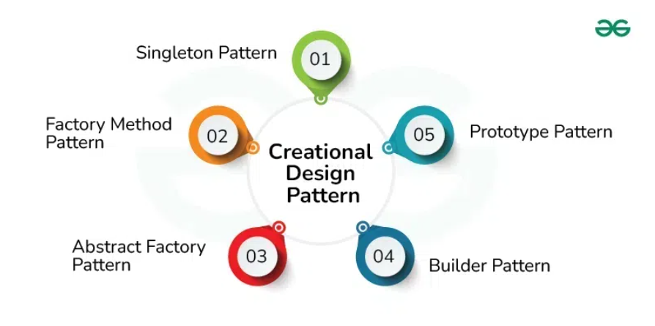
- Singleton design pattern
The Singleton Design Pattern is a creational pattern that ensures a class has only one instance and provides a global point of access to that instance.
In other words, a class must ensure that only single instance should be created and single object can be used by all other classes.
- Early Instantiation: creation of instance at load time.
- Lazy Instantiation: creation of instance when required.

Advantage of Singleton design pattern
- Saves memory because object is not created at each request. Only single instance is reused again and again.
Usage of Singleton design pattern
- Singleton pattern is mostly used in multi-threaded and database applications. It is used in logging, caching, thread pools, configuration settings etc.

How to create Singleton design pattern?
To create the singleton class, we need to have static member of class, private constructor and static factory method.
- Static member: It gets memory only once because of static, it contains the instance of the Singleton class.
- Private constructor: It will prevent to instantiate the Singleton class from outside the class.
- Static factory method: This provides the global point of access to the Singleton object and returns the instance to the caller.
public class Singleton {
// Static variable to hold the single instance of the class
// The below field is static because we are accessing it in static field
//The instance variable is marked as private to restrict direct access to it from outside the Singleton class.
private static Singleton instance; // This is a lazy way of creating a singleton object
// Private constructor to prevent instantiation from outside
private Singleton() {
}
// Public method to provide the global point of access to the instance
// getInstance() method is marked as static because it allows the method to be called without creating an instance of the class.
public static Singleton getInstance() {
if (instance == null) {
// Create a new instance if it doesn't exist
instance = new Singleton();
}
return instance;
}
}
Explanation:
- Private Constructor: Prevents the creation of an instance from outside the class, ensuring that the class can only be instantiated internally.
- Static Method (getInstance): Ensures that only one instance of the class is created. If an instance already exists, it returns the existing one; otherwise, it creates and returns a new instance.
- Lazy Initialization: The instance is created only when it’s needed, i.e., when getInstance() is called for the first time.
public class Singleton1 {
//Eager way of creating singleton object
private static Singleton1 instance1 = new Singleton1();
public static Singleton1 getInstance1(){
return instance1;
}
}
OUTPUT:
public class Example {
public static void main(String[] args) {
Singleton singleton = Singleton.getInstance();
Singleton singleton1 = Singleton.getInstance();
System.out.println(singleton.hashCode()); //2065951873
System.out.println(singleton1.hashCode()); //2065951873
//both print statement will give same hashcode value
//Eager Way object will also give same hashcode value (ie. 4345.., 4345..)
}
}
Q. What is difference between Lazy Instantiation and Early/Eager Instantiation?
1. Lazy Instantiation (Lazy Initialization):
- Definition: In lazy instantiation, the Singleton instance is created only when it is first requested (i.e., when it is actually needed).
- Creation: The instance is created when the getInstance() method is called for the first time.
- Thread Safety: In a multithreaded environment, lazy instantiation needs extra precautions (like synchronization) to ensure that two threads do not create multiple instances simultaneously.
Pros:
- Efficient resource use: The Singleton instance is only created when it is needed, avoiding unnecessary memory allocation.
- Useful in scenarios where the instance might never be needed, saving resources.
Cons:
- Thread safety issues: Without proper synchronization, lazy instantiation may lead to multiple instances being created in a multithreaded environment.
- Performance overhead: Adding thread-safety mechanisms like synchronized can slightly affect performance.

2. Early Instantiation (Eager Initialization):
- Definition: In early instantiation, the instance of the Singleton class is created at the time the class is loaded by the JVM, even if the instance is never used.
- Creation: The Singleton instance is created as soon as the class is loaded into memory, whether or not it is ever accessed.
- Thread Safety: This approach is naturally thread-safe because the instance is created at class loading time and remains consistent across threads.
Pros:
- Simple to implement.
- Naturally thread-safe, as the instance is created at class loading time.
Cons:
- Wasted resources: If the Singleton instance is never actually needed, memory is unnecessarily allocated for it.
- No control over when it's created: The instance is created even if it's never used in the application.

Thread-Safe Singleton:
In a multithreaded environment, If multiple thread try to create a instance of singleton class then in that case two instance will be get created.
In a multithreaded environment, you may need to ensure that two threads don't create separate instances. A simple way to make the Singleton thread-safe is by using synchronization

public class Singleton {
private static Singleton instance;
private Singleton() {
}
public static Singleton getInstance() {
if (instance == null) {
// Create a new instance if it doesn't exist
synchronized (Singleton.class){
if (instance == null) {
instance = new Singleton();
}
}
}
return instance;
}
}
(we are using synchronized block for a particular code which need synchronization, we are avoiding synchronized method for synchronization because it will synchronize an un-necessary code present in method)

# 3 Ways to break singleton pattern
1. Reflection
Reflection is a powerful feature in Java that allows access to private fields and methods of a class at runtime. Using reflection, it's possible to bypass the private constructor of a Singleton class and create multiple instances.
import java.lang.reflect.Constructor;
class Singleton {
private static Singleton instance = new Singleton(); // Early instantiation
private Singleton() {
// Prevent instance creation using reflection
if (instance != null) {
throw new IllegalStateException("Instance already created!");
}
}
public static Singleton getInstance() {
return instance;
}
}
public class ReflectionTest {
public static void main(String[] args) {
Singleton singleton1 = Singleton.getInstance();
Singleton singleton2 = null;
try {
// Access the private constructor using reflection
Constructor<Singleton> constructor = Singleton.class.getDeclaredConstructor();
constructor.setAccessible(true); // Bypass the private constructor
singleton2 = constructor.newInstance(); // Create a new instance
} catch (Exception e) {
e.printStackTrace();
}
// This will print two different instances, breaking Singleton
System.out.println(singleton1.hashCode());
System.out.println(singleton2.hashCode());
}
}
To prevent breaking the Singleton pattern via reflection, you can modify the constructor to throw an exception if an instance already exists. also you can use ENUM to prevent this breaking from reflection, to know more about handling using ENUM refer Code with Durgesh Design pattern video no 3.
2. Serialization and Deserialization
Serialization involves converting an object into a byte stream, which can be saved and later deserialized to create a new object. If the Singleton class is serializable (i.e., implements Serializable), deserialization can create a new instance, breaking the Singleton.
import java.io.*;
class Singleton implements Serializable {
private static Singleton instance = new Singleton();
private Singleton() {}
public static Singleton getInstance() {
return instance;
}
}
public class SerializationTest {
public static void main(String[] args) {
Singleton singleton1 = Singleton.getInstance();
try {
// Serialize the instance
ObjectOutputStream oos = new ObjectOutputStream(new FileOutputStream("singleton.ser"));
oos.writeObject(singleton1);
oos.close();
// Deserialize to create a new instance
ObjectInputStream ois = new ObjectInputStream(new FileInputStream("singleton.ser"));
Singleton singleton2 = (Singleton) ois.readObject();
ois.close();
// This will print two different instances, breaking Singleton
System.out.println(singleton1.hashCode());
System.out.println(singleton2.hashCode());
} catch (Exception e) {
e.printStackTrace();
}
}
}

Solution:
To prevent breaking Singleton via serialization, implement the readResolve() method, which returns the existing instance during deserialization rather than creating a new one.
// Add this method to the Singleton class
protected Object readResolve() {
return getInstance(); // Return the existing instance
}

3. Cloning
In Java, if a Singleton class implements the Cloneable interface, it allows the creation of a copy of the Singleton instance using the clone() method, breaking the Singleton pattern by generating a new instance.
class Singleton implements Cloneable {
private static Singleton instance = new Singleton();
private Singleton() {}
public static Singleton getInstance() {
return instance;
}
@Override
protected Object clone() throws CloneNotSupportedException {
return super.clone(); // This creates a new instance, breaking Singleton
}
}
public class CloningTest {
public static void main(String[] args) {
Singleton singleton1 = Singleton.getInstance();
Singleton singleton2 = null;
try {
singleton2 = (Singleton) singleton1.clone(); // Cloning the singleton
} catch (CloneNotSupportedException e) {
e.printStackTrace();
}
// This will print two different instances, breaking Singleton
System.out.println(singleton1.hashCode());
System.out.println(singleton2.hashCode());
}
}

Solution:
To prevent breaking the Singleton pattern via cloning, you can override the clone() method and throw a CloneNotSupportedException to prevent cloning. Or you can directly return the instance of a instance variable of singleton
@Override
protected Object clone() throws CloneNotSupportedException {
// throw new CloneNotSupportedException("Singleton class can't be cloned!"); //or
return instance; // or we can directly return the instance of singleton
}

- Singleton design pattern
A Factory design pattern that just define an interface or abstract class for creating an object but let the subclasses decide which class to instantiate. In other words, subclasses are responsible to create the instance of the class.
The Factory Method Pattern is also known as Virtual Constructor.
The Factory pattern is useful when:
- You need to create instances of multiple derived classes based on a certain condition.
- You want to hide the creation logic of the object from the client.
- The classes you instantiate depend on runtime conditions.

Example Scenario
Suppose we are building a program that allows users to order different types of vehicles: Car, Bike, and Truck. Using the Factory pattern, we can define a VehicleFactory that will create the appropriate type of vehicle based on the input.

Step-by-Step Example
- Define the Product Interface: Create an interface that represents the type of product the factory will create (i.e., Vehicle).
public interface Vehicle {
void design(); // method to define design
void manufacture(); // method to define manufacturing process
}
- Implement Concrete Products: Implement different types of products that extend the Vehicle interface (e.g., Car, Bike and Truck).
public class Car implements Vehicle {
@Override
public void design() {
System.out.println("Designing Car...");
}
@Override
public void manufacture() {
System.out.println("Manufacturing Car...");
}
}
public class Bike implements Vehicle {
@Override
public void design() {
System.out.println("Designing Bike...");
}
@Override
public void manufacture() {
System.out.println("Manufacturing Bike...");
}
}
- Create the Factory Class: The VehicleFactory will contain a static method to create the appropriate Vehicle instance based on the input.
public class VehicleFactory {
// Factory method to create vehicles
public static Vehicle getVehicle(String type) {
switch (type.toLowerCase()) {
case "car":
return new Car();
case "bike":
return new Bike();
default:
throw new IllegalArgumentException("Unknown vehicle type.");
}
}
}
- Using the Factory to Create Objects: The client (e.g., Main class) will use VehicleFactory.getVehicle() to get instances of different vehicles without knowing their concrete types.
public class Main {
public static void main(String[] args) {
// Request different vehicle types through the factory
Vehicle car = VehicleFactory.getVehicle("car");
car.design();
car.manufacture();
Vehicle bike = VehicleFactory.getVehicle("bike");
bike.design();
bike.manufacture();
}
}
When you run the Main class, the output will be as follows:
Designing Car...
Manufacturing Car...
Designing Bike...
Manufacturing Bike...
Explanation
- Encapsulation of Object Creation: VehicleFactory hides the instantiation of Car, Bike, and Truck classes. The client only interacts with VehicleFactory and does not need to know the specifics of each Vehicle implementation.
- Loose Coupling: The client is only dependent on the Vehicle interface, not on the specific classes (Car, Bike, Truck).
- Single Responsibility Principle: The factory is solely responsible for creating Vehicle objects. Each concrete class focuses on its own specific behavior.
Advantages of Factory Pattern
- Encapsulates Object Creation: The factory handles all the logic for creating instances, making it easier to change the instantiation logic later if needed.
- Promotes Loose Coupling: The client code is only coupled to the Vehicle interface, not the concrete classes, making it easier to swap implementations.
- Follows Open-Closed Principle: You can add new types (e.g., a Bus class) without modifying the existing classes, simply by adding a new case in the VehicleFactory.
Disadvantages of Factory Pattern
- More Classes to Maintain: Each product type requires its own class, which could increase the number of classes in the application.
- Complexity: For very simple instantiation scenarios, the Factory pattern might add unnecessary complexity.

3. Abstract Factory Pattern
The Abstract Factory Pattern is a creational design pattern that provides an interface to create families of related or dependent objects without specifying their concrete classes. It’s often called a "factory of factories" because it creates related factories, each capable of producing a set of objects.
This pattern is beneficial when:
- You need to create a set of related objects.
- The types of objects to be created are dependent on a particular configuration or environment.
- You want to ensure that these related objects work well together.

Structure of Abstract Factory Pattern
- Abstract Factory: Declares an interface for creating each type of product.
- Concrete Factory: Implements the creation methods to produce concrete products.
- Abstract Product: Defines the interface for a type of product.
- Concrete Product: Implements the product interface and represents a specific type of product.
Example Scenario
Consider a scenario where we need to create UI elements (like buttons and checkboxes) for different platforms: Windows and MacOS. Each platform has its specific style for buttons and checkboxes. Using the Abstract Factory pattern, we can design a solution where each UI element (e.g., Button, Checkbox) is created by a factory tailored to each platform.

Step-by-Step Implementation
1. Define the Abstract Product Interfaces
Create interfaces for each product type, like Button and Checkbox.
// Abstract Product - Button
public interface Button {
void paint();
}
// Abstract Product - Checkbox
public interface Checkbox {
void paint();
}
2. Implement Concrete Products
Create platform-specific implementations of each product. For example, WindowsButton, MacButton, WindowsCheckbox, and MacCheckbox.
// Concrete Product - WindowsButton
public class WindowsButton implements Button {
@Override
public void paint() {
System.out.println("Rendering Windows Button.");
}
}
// Concrete Product - WindowsCheckbox
public class WindowsCheckbox implements Checkbox {
@Override
public void paint() {
System.out.println("Rendering Windows Checkbox.");
}
}
// Concrete Product - MacButton
public class MacButton implements Button {
@Override
public void paint() {
System.out.println("Rendering Mac Button.");
}
}
// Concrete Product - MacCheckbox
public class MacCheckbox implements Checkbox {
@Override
public void paint() {
System.out.println("Rendering Mac Checkbox.");
}
}
3. Define the Abstract Factory Interface
The abstract factory (GUIFactory) declares methods to create each type of product, in this case, Button and Checkbox.
// Abstract Factory Interface
public interface GUIFactory {
Button createButton();
Checkbox createCheckbox();
}
4. Implement Concrete Factories
Each concrete factory will create products tailored to a specific platform.
// Concrete Factory - WindowsFactory
public class WindowsFactory implements GUIFactory {
@Override
public Button createButton() {
return new WindowsButton();
}
@Override
public Checkbox createCheckbox() {
return new WindowsCheckbox();
}
}
// Concrete Factory - MacFactory
public class MacFactory implements GUIFactory {
@Override
public Button createButton() {
return new MacButton();
}
@Override
public Checkbox createCheckbox() {
return new MacCheckbox();
}
}
5. Create Client Code
The client code will work with the abstract factory (GUIFactory), meaning it doesn’t need to know the specifics of the Windows or Mac implementations. The client receives a factory instance according to the configuration, and the factory provides the appropriate objects.
// Client Code
public class Application {
private Button button;
private Checkbox checkbox;
// Constructor initializes the application with a GUIFactory
public Application(GUIFactory factory) {
button = factory.createButton();
checkbox = factory.createCheckbox();
}
// Method to paint the UI components
public void paint() {
button.paint();
checkbox.paint();
}
}
6. Configuration and Testing
A factory instance (WindowsFactory or MacFactory) is created based on configuration (e.g., runtime setting or environment). This factory is passed to the Application to create platform-specific UI elements.
public class Main {
private static Application configureApplication() {
Application app;
GUIFactory factory;
// For demonstration, we assume the OS is Windows. Change this to test Mac.
String osName = "Windows";
if (osName.equalsIgnoreCase("Windows")) {
factory = new WindowsFactory();
} else {
factory = new MacFactory();
}
app = new Application(factory);
return app;
}
public static void main(String[] args) {
Application app = configureApplication();
app.paint();
}
}
Output
Running the Main class with the osName set to "Windows" would yield the following output:
Rendering Windows Button.
Rendering Windows Checkbox.
If osName were set to "Mac", the output would be:
Rendering Mac Button.
Rendering Mac Checkbox.

Explanation
- Factory Creation: The configureApplication method determines which factory to use based on the environment or configuration.
- Encapsulation of Product Families: The Application class only interacts with the GUIFactory interface and Button and Checkbox interfaces, making the platform-specific details hidden from it.
- Platform Flexibility: Adding a new platform would only require a new factory (e.g., LinuxFactory) and new product classes (LinuxButton, LinuxCheckbox) without modifying existing client code.
Benefits of Abstract Factory Pattern
- Encapsulation of Object Families: Each factory can produce a set of related objects, keeping these families consistent.
- Loose Coupling: The client code interacts only with interfaces and abstract factories, reducing dependency on specific classes.
- Single Responsibility Principle: Each factory class has a single responsibility to create products specific to a platform.

Drawbacks of Abstract Factory Pattern
- Complexity: It introduces multiple interfaces and concrete classes, which can lead to more code.
- Difficulty in Extending Families: Adding a new type of product (e.g., Slider) across all families would require modifying all existing factories to include a new createSlider method.

The Abstract Factory Pattern is widely used in GUI toolkits like Swing and AWT, where different LookAndFeel implementations (Windows, Mac, Motif, etc.) are created using abstract factories to ensure consistent design across components. This pattern is also applied in other scenarios where different environments require cohesive object families, like database interaction libraries or cross-platform application development.

2. Structural Design Patterns in Java
Structural design patterns focus on how classes and objects are arranged to create larger, more complex structures in software development. They help organize relationships between objects, making systems more flexible, reusable, and maintainable. By using these patterns, developers can create easier-to-understand and modify systems.
Types of Structural Design Patterns in Java:
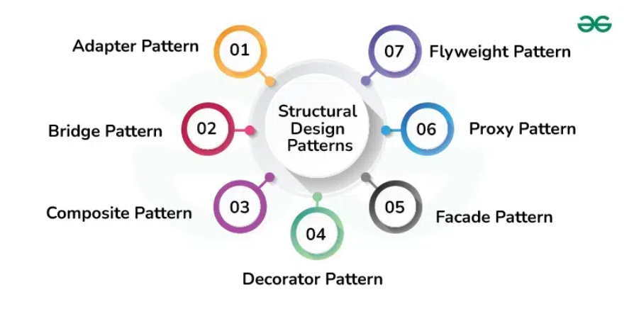

3. Behavioral Design Patterns in Java
Behavioral design patterns are a group of design patterns that focus on how objects and classes interact and communicate in software development. They emphasize the collaboration between objects to effectively accomplish tasks and responsibilities, making the system more manageable and adaptable
